|  |  |
| --- | --- |
| **TEAM ID** | PNT2022TMID17581 |
| **Project Name** | Smart farmer-IOT Enabled smart farming application |

**AN ACCOUNT WAS CREATED IN MIT APP INVENTOR AND FEATURES WERE OVERVIEWED**

# DESIGNER

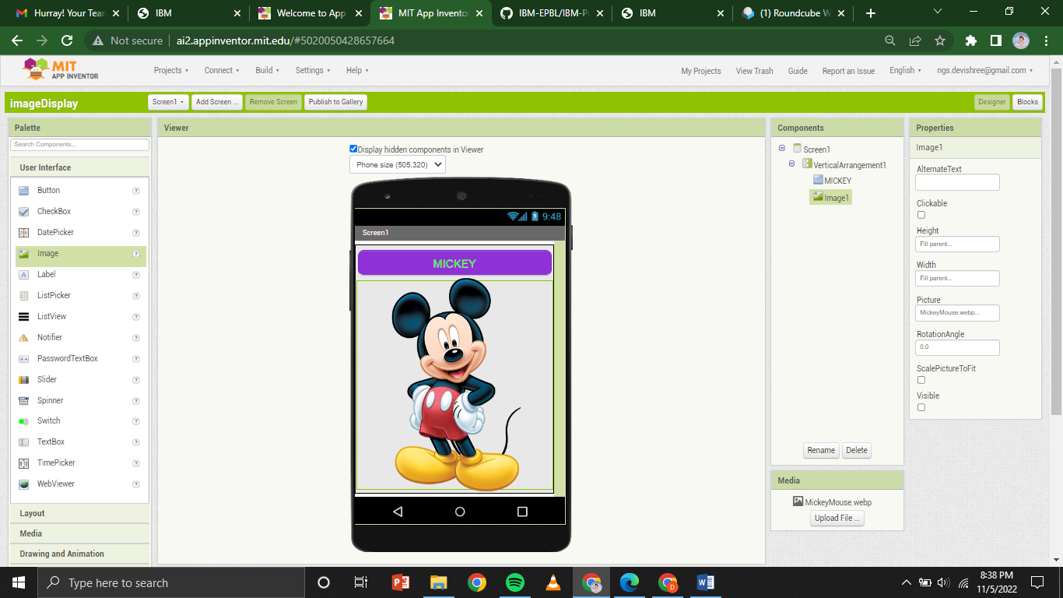

# BLOCKS

# 

